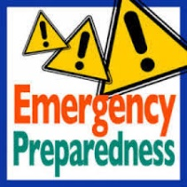
Emergency Preparedness Corner
Be Prepared, Not Scared
Did you feel our 4.6 earthquake near Monroe in July? Are you prepared at home for an emergency or a disaster? Here are 12 ways you can get ready (click on the picture):
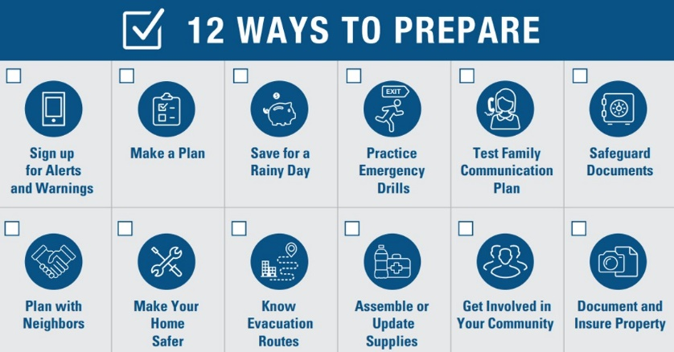
Northshore School District Emergency Reunification
The Northshore School District has created a standard Emergency Reunification process for all schools and conducted a drill in May 2019. For information on the process (Click Here)
[School Name] Family Reunification
Do you know what to do in the case of an emergency or crisis during school hours?
Do not rush to school to pick up your child. Our school is in an area where the additional traffic may impede needed emergency vehicles or personnel from arriving. If a school evacuation is ordered, your presence at the site could delay evacuation and reunification. When the situation is under control, students and parents will be reunited in a safe, orderly, and timely manner.
- Wait for notification from Leota or the district for the pickup process. Your student could be relocated via bus to one of three or more reunification sites depending on the situation.
- ALL PARENTS AND EMERGENCY CONTACTS must have picture identification to pick up the student.
- The parent, guardian, trusted neighbor or authorized emergency contact’s name must be in ParentVUE
Please take this opportunity to update the emergency contacts in ParentVue and consider including trusted neighbors or others that can respond to the reunification sites in case your response is delayed by other emergencies happening in our region.
How Can you Help?
Please remind your emergency contacts that when picking up a student during an emergency, everyone must have picture identification. These additional contacts will be critical if you cannot pick up your student.
- Ensure you have a ParentVUE account. If you do not have an account, contact Leota and request your 7-digit activation key.
- Login to ParentVUE, click on “Student Info” in the left-hand menu. Click the Edit Information button.
- Scroll down to find the Emergency Contacts area. Update existing emergency contacts and enter new contacts here.
- Click the “Save Changes” button at the bottom of the screen.

The Great Washington Shake Out: October 17th
On October 17, at 10:17am, Leota will be participating in the Great Washington Shake Out, an earthquake preparedness drill. Participating is a great way for your family or organization to be prepared to survive and recover quickly from big earthquakes– wherever you live, work, or travel. Remember to drop, cover and hold during an earthquake! Stay where you are for several minutes afterward, bracing for possible aftershocks. Click on the picture for more information.

Emergency Supplies
Did you know…. that the supplies used in an emergency by the students and staff of [School Name] are funded by the Leota PTSA (Parent Teacher Student Association)! Parents thank you for your donations to our PTSA.

Picture of School E-Prep Container

