A free clothing resource for families of Northshore School District
Located at Canyon Park Middle School
Open Wednesdays 3-6pm &
the First Saturday of the Month 9-12pm
August 28, 2019 – June 24, 2020
Threads & Treads will be closed during NSD breaks and school closures
Threads & Treads provides Northshore families free, quality donated clothing for school age youth, teens, young adults and their parents. Clothing items include appropriate clothing and fashions for school, special events, career, sports/recreation, shoes & accessories. No pre-registration or appointments necessary.

abierto los miércoles 3-6pm y el primer sábado del mes 9-12pm
Situado en Canyon Park Middle School, Hilos y Pasos es un banco de ropa gratis para las familias del distrito escolar de Northshore. No es necesario prerregistro ni citas.
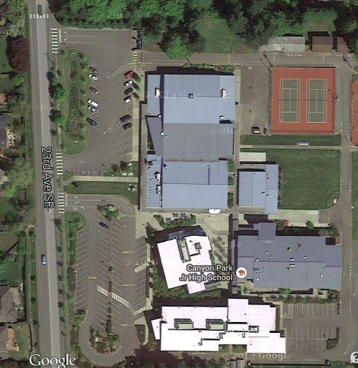

23723 23rd Ave SE, Bothell, WA 98021
Clothing donations can be dropped off during open hours or at CPMS main office 7:30am-4pm; donations go into containers at the entry of office.
¿ Tiene Preguntas ? Questions? Email tandt@cpptsa.org

Canyon Park Middle School PTSA operates Threads & Treads in partnership with NSD
https://cpptsa.org/programs-activities/threads-treads/

