Sample Electronic Voting (E-Voting) Policy for Local PTAs:

In the event that ballot voting cannot be accomplished at an in person membership meeting, [PTA name] will allow for ballot voting to take place via electronic transmission utilizing an online voting tool or survey. This policy establishes best practices for this ballot voting format.

FORMAT OF ELECTION:

- The first notice of an election that is to be conducted via electronic means will be sent to members in good standing at least 14 days prior to the election and must include:
  - Announcement of voting method being utilized, as well as procedure.
  - The date that the full list of nominees and the link to the online voting tool or survey ballot will be sent to members in good standing.
  - The full list of nominees (for nominating committee elections) or the Nominating Committee Report (for officer elections).
  - Provision for self-declared nominations.
  - Instructions for how to self-declare, including the link to online survey, if applicable.
  - Length of time self-declaration period is open (recommended at least 7 days).
  - The eligibility requirements for election.
- If self-declarations are received, efforts must be taken to verify information and eligibility for positions. In the case of nominating committee positions, the president will designate a board member to fill this role. In the case of officer elections, the Nominating Committee will fill this role. All eligible self-declared nominees must be contacted and informed of the addition of their name to the final survey ballot.

If there is only one candidate for a position:

- The second notification of an election conducted by electronic means will be sent to members in good standing and must include:
  - The full list of nominees (for nominating committee elections) or the names of all officer candidates (for officer elections).
  - Date, time, and place of the membership meeting during which the election vote is to take place (recommended at least 7 days from date of electronic transmission).
- At the designated membership meeting, the election is held via voice vote (roll call) as per WSPTA Bylaws, Article 5, Section 6.B.
- Record the election results in the meeting minutes.

If there is more than one candidate for a position:

- The president shall appoint a tellers committee of 2-3 individuals to count votes and confirm quorum. (See TELLERS COMMITTEE procedure below.)
- The second notification of an election conducted by electronic means will be sent to members in good standing and must include:
  - The full list of nominees (for nominating committee elections) or the Nominating Committee report (for officer elections), as well as all self-declared candidates who meet eligibility requirements.
  - Instructions on how to access the ballot via online voting tool or survey.
  - Deadline for the completion of survey ballots (recommended 7 days from date of electronic transmission).
  - Date, time, and place of the membership meeting announcing results.
- Upon reaching the survey ballot deadline, the tellers committee will tally results and deliver the Tellers Report to the president.
- The president will deliver the results at the predetermined membership meeting date, time and place.
- The Tellers Report will be added to the minutes of the membership meeting at which the election results are announced.

TELLERS COMMITTEE:

- The president shall appoint a tellers committee of 2-3 individuals to count votes and confirm quorum.
- Each appointed teller must sign a non-disclosure agreement stating that they will keep all details of voting confidential, except for the final report provided to the president.
- The tellers committee must create an online survey ballot to be sent to members. An online survey ballot can be created using a number of different tools, including, but not limited to, Google Forms, Survey Monkey, Zoomerang, et. al. The survey tool used must be able to support the ballot requirements. The survey ballot shall include:
  - Brief description of the voting procedure
  - Survey ballot return deadline
  - Full list of all nominees or complete text of proposed motion
  - Survey respondent name, PTA and email
- The tellers committee must verify that each survey ballot is from an eligible voter per Northshore Council PTSA Standing Rules. Each completed survey ballot counts towards quorum.
- Blank survey ballots may count towards quorum. A blank survey ballot is similar to an abstaining vote.
- If a survey ballot is in any way ambiguous, it may count toward quorum but not as a vote.
- The tellers committee tallies the survey ballot votes. Example tally sheet:

- The tellers committee creates a Tellers Report. Example Tellers Report:
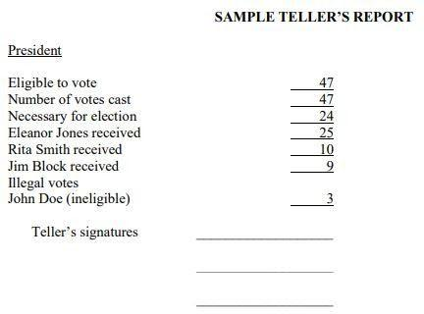

- The Tellers Report will be added to the minutes of the membership meeting at which the election results are announced.
- All electronic transmissions regarding voting and online survey ballots shall be permanently deleted by the tellers committee by June 30th of the year the election is held.

